Ex 1 :
import pandas as pd
import numpy as np

# Load dataset
data = pd.read_csv("weather_dataset.csv")

# Separate attributes and target
attributes = np.array(data.iloc[:, :-1])
target = np.array(data.iloc[:, -1])

# Find-S Algorithm
def find_s(attributes, target):
hypothesis = None

for i in range(len(target)):
if target[i] == "Yes":
if hypothesis is None:
hypothesis = attributes[i].copy()
else:
for j in range(len(hypothesis)):
if hypothesis[j] != attributes[i][j]:
hypothesis[j] = '?'

return hypothesis
# Run algorithm
final_hypothesis = find_s(attributes, target)

print("Final Hypothesis:", final_hypothesis)
procedure
• Initialize hypothesis
- Start with the most specific hypothesis
- Example: h = NULL (or first positive example)
• Read training examples
- Each example has attributes + target (Yes/No)
• Consider only positive examples
- Ignore all negative examples
• For first positive example
- Set hypothesis = that example
• For each next positive example
- Compare with current hypothesis:
  - If attribute values match → keep same
  - If different → replace with ? (generalize)
• Repeat for all training data
• Final hypothesis
- Most specific hypothesis that covers all positive examples
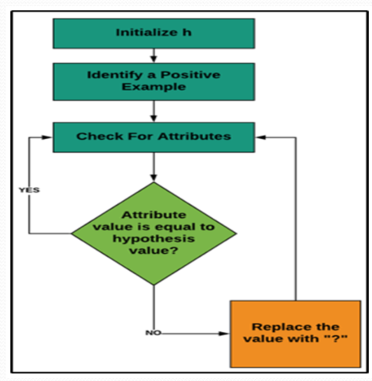

Ex: 2
Algorithm:
Step1: Load Data set
Step2: Initialize General Hypothesis and Specific Hypothesis.
Step3: For each training example
Step4: If example is positive example
if attribute_value == hypothesis_value:
Do nothing
else:
replace attribute value with '?' (Basically generalizing it)
Step5: If example is Negative example
Make generalize hypothesis more specific.
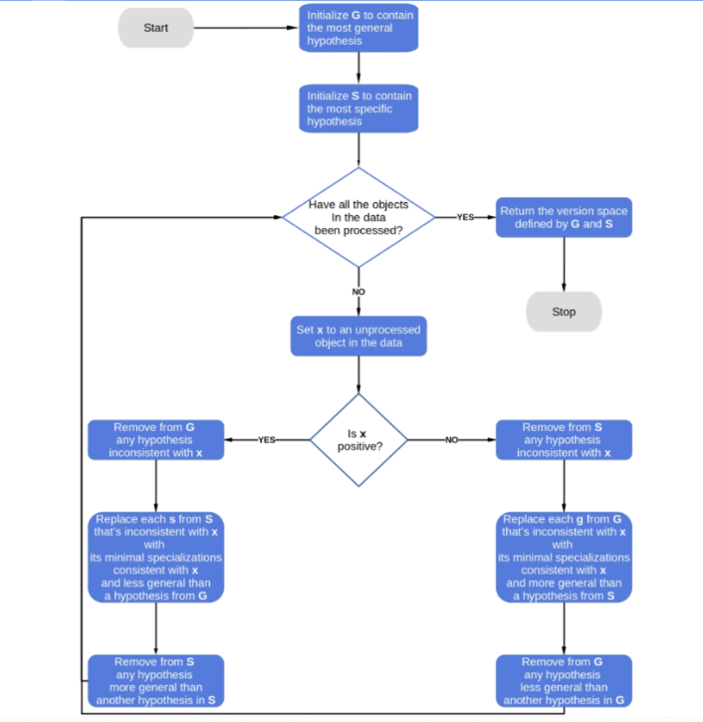
import pandas as pd
import numpy as np
# Load dataset
data = pd.read_csv("weather_dataset.csv")
# Separate attributes and target
concepts = np.array(data.iloc[:, :-1])
target = np.array(data.iloc[:, -1])
def candidate_elimination(concepts, target):
specific_h = concepts[0].copy()
general_h = [["?" for _ in range(len(specific_h))] for _ in range(len(specific_h))]
for i in range(len(concepts)):
if target[i] == "Yes": # Positive example
for j in range(len(specific_h)):
if concepts[i][j] != specific_h[j]:
specific_h[j] = '?'
general_h[j][j] = '?'
else: # Negative example
for j in range(len(specific_h)):
if concepts[i][j] != specific_h[j]:
general_h[j][j] = specific_h[j]
else:
general_h[j][j] = '?'
# Remove overly general hypotheses
general_h = [g for g in general_h if any(val != '?' for val in g)]
return specific_h, general_h
# Run algorithm
s_final, g_final = candidate_elimination(concepts, target)
print("Final Specific Hypothesis:", s_final)
print("Final General Hypothesis:", g_final)

Ex 3:
Step 1: Set a minimum support and confidence
Step 2: Take all the subset present in the transactions which
have higher support.
Step 3: Take all the rules of these subsets which have higher
confidence.
Step 4: Sort the rules by decreasing lift.
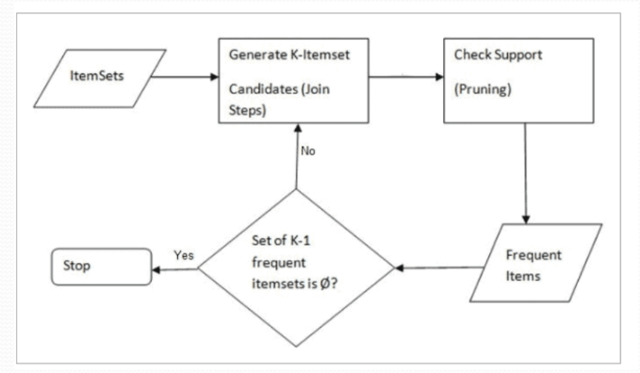
import pandas as pd
from efficient_apriori import apriori

# Load dataset
data = pd.read_csv("ex3dataset.csv", header=None)
# Convert to transactions
transactions = [row[0].split(",") for row in data.values]
# Apply Apriori
itemsets, rules = apriori(transactions, min_support=0.3, min_confidence=0.6)
# Print frequent itemsets
print("Frequent Itemsets:\n")
for k, itemset in itemsets.items():
for items, support in itemset.items():
print(f"{set(items)} : {support:.2f}")
# Print rules
print("\nAssociation Rules:\n")
for rule in rules:
print(f"{set(rule.lhs)} -> {set(rule.rhs)} | "
f"Support: {rule.support:.2f}, "
f"Confidence: {rule.confidence:.2f}, "
f"Lift: {rule.lift:.2f}")

ex: 4
• Import libraries
- Import Pandas, Matplotlib, and modules from Scikit-learn.
• Load dataset
- Read the Iris dataset using pd.read_csv().
• Select features
- Choose PetalLength as input (X).
- Choose SepalLength as output (y).
• Split dataset
- Divide data into training and testing sets using train_test_split().
• Train model
- Create Linear Regression model.
- Fit the model with training data.
• Make predictions
- Predict values for test data using the trained model.
• Evaluate model
- Calculate:
  - Slope (coefficient)
  - Intercept
  - Mean Squared Error (MSE)
  - R² Score
• Visualize results (Training set)
- Plot data points and regression line.
• Visualize results (Test set)
- Plot test data and predicted regression line.

Linear Regression (Clean Code)
import pandas as pd
import matplotlib.pyplot as plt
from sklearn.model_selection import train_test_split
from sklearn.linear_model import LinearRegression
from sklearn.metrics import mean_squared_error, r2_score

# Load dataset
data = pd.read_csv("iris.csv")

# Select features
X = data[['PetalLength']]
y = data['SepalLength']

# Split data
X_train, X_test, y_train, y_test = train_test_split(X, y, test_size=0.3)

# Train model
model = LinearRegression()
model.fit(X_train, y_train)

# Predict
y_pred = model.predict(X_test)

# Evaluation
print("Slope:", model.coef_)
print("Intercept:", model.intercept_)
print("MSE:", mean_squared_error(y_test, y_pred))
print("R2 Score:", r2_score(y_test, y_pred))

# Visualization (Training data)
plt.scatter(X_train, y_train)
plt.plot(X_train, model.predict(X_train))
plt.xlabel("Petal Length")
plt.ylabel("Sepal Length")
plt.title("Training Set")
plt.show()

# Visualization (Test data)
plt.scatter(X_test, y_test)
plt.plot(X_test, y_pred)
plt.xlabel("Petal Length")
plt.ylabel("Sepal Length")
plt.title("Test Set")
plt.show()
Logistic Regression Code
Procedure: Logistic Regression (Diabetes Dataset)
- Import required libraries
  - Import NumPy, Matplotlib, and modules from Scikit-learn for model building and evaluation.
- Load dataset
  - Load diabetes dataset using load_diabetes().
- Prepare data
  - Extract features (X) and target (y).
  - Convert target into binary classes (0 and 1) using median value.
- Split dataset
  - Divide data into training and testing sets using train_test_split().
- Feature scaling
  - Apply StandardScaler to normalize data for better model performance.
- Train model
  - Create Logistic Regression model.
  - Fit the model using training data.
- Make predictions
  - Predict output values for test data.
- Evaluate model
  - Calculate accuracy using accuracy_score.
  - Generate confusion matrix and classification report.
- Plot ROC curve
  - Compute probabilities using predict_proba().
  - Plot ROC curve and calculate AUC value.
- Display results
- Show accuracy, metrics, and ROC graph.

import numpy as np
import matplotlib.pyplot as plt
from sklearn.datasets import load_diabetes
from sklearn.model_selection import train_test_split
from sklearn.preprocessing import StandardScaler
from sklearn.linear_model import LogisticRegression
from sklearn.metrics import accuracy_score, confusion_matrix, classification_report, roc_curve, auc

# Load dataset
data = load_diabetes()
X = data.data
y = data.target

# Convert to binary classification
y = (y > np.median(y)).astype(int)

# Split data
X_train, X_test, y_train, y_test = train_test_split(X, y, test_size=0.2)

# Standardize
scaler = StandardScaler()
X_train = scaler.fit_transform(X_train)
X_test = scaler.transform(X_test)

# Train model
model = LogisticRegression()
model.fit(X_train, y_train)

# Predict
y_pred = model.predict(X_test)

# Evaluation
print("Accuracy:", accuracy_score(y_test, y_pred))
print("Confusion Matrix:\n", confusion_matrix(y_test, y_pred))
print("Classification Report:\n", classification_report(y_test, y_pred))

# ROC Curve
y_prob = model.predict_proba(X_test)[:, 1]
fpr, tpr, _ = roc_curve(y_test, y_prob)
roc_auc = auc(fpr, tpr)
plt.plot(fpr, tpr, label=f"AUC = {roc_auc:.2f}")
plt.plot([0,1],[0,1],'--')
plt.xlabel("FPR")
plt.ylabel("TPR")
plt.title("ROC Curve")
plt.legend()
plt.show()

Ex : 5

Short Decision Tree (ID3) Code
import pandas as pd
from sklearn.model_selection import train_test_split
from sklearn.tree import DecisionTreeClassifier, plot_tree, export_text
from sklearn.preprocessing import LabelEncoder
from sklearn.metrics import accuracy_score
import matplotlib.pyplot as plt
# Load dataset
data = pd.read_csv("weather_dataset.csv")
# Encode categorical data
le = LabelEncoder()
for col in data.columns:
data[col] = le.fit_transform(data[col])
# Split features and target
X = data.iloc[:, :-1]
y = data.iloc[:, -1]
# Train-test split
X_train, X_test, y_train, y_test = train_test_split(X, y, test_size=0.3)
# Train Decision Tree (ID3 → entropy)
model = DecisionTreeClassifier(criterion='entropy')
model.fit(X_train, y_train)
# Prediction & accuracy
y_pred = model.predict(X_test)
print("Accuracy:", accuracy_score(y_test, y_pred))
# Print rules
print("\nDecision Tree Rules:\n")
print(export_text(model, feature_names=list(X.columns)))
# Plot tree
plt.figure(figsize=(10,6))
plot_tree(model, feature_names=X.columns, class_names=["No","Yes"], filled=True)
plt.show()
# Predict new sample
sample = [[1, 0, 1, 0]] # Example input
print("\nPrediction:", model.predict(sample))
Procedure: Decision Tree (ID3 Algorithm)
- Import libraries
  - Import Pandas, Matplotlib, and modules from Scikit-learn.
- Load dataset
  - Read the dataset using pd.read_csv().
- Preprocess data
  - Convert categorical values into numeric form using LabelEncoder.
- Split features and target
  - Separate input features (X) and target variable (y).
- Split dataset
  - Divide data into training and testing sets using train_test_split().
- Train model
  - Create Decision Tree model using criterion='entropy' (ID3).
  - Fit the model using training data.
- Make predictions
  - Predict target values for test data.
- Evaluate model
  - Calculate accuracy using accuracy_score().
- Display rules
  - Extract decision rules using export_text().
- Visualize tree
- Plot the decision tree using plot_tree().
- Predict new sample
- Provide new input data and predict its class.
Ex :6
import pandas as pd
from sklearn.preprocessing import LabelEncoder
from sklearn.model_selection import train_test_split
from sklearn.naive_bayes import GaussianNB
from sklearn.metrics import accuracy_score

# Load dataset
data = pd.read_csv("weather_dataset.csv")

# Encode categorical data
data = data.apply(LabelEncoder().fit_transform)

# Split features and target
X = data.iloc[:, :-1]
y = data.iloc[:, -1]

# Train-test split
X_train, X_test, y_train, y_test = train_test_split(X, y, test_size=0.2)

# Train model
model = GaussianNB()
model.fit(X_train, y_train)

# Predict & evaluate
y_pred = model.predict(X_test)
print("Accuracy:", accuracy_score(y_test, y_pred))

Procedure: Naïve Bayes Classifier
- Import libraries
  - Import Pandas and modules from Scikit-learn.
- Load dataset
  - Read dataset using pd.read_csv().
- Preprocess data
  - Convert categorical values into numeric using LabelEncoder.
- Split features and target
  - Separate input (X) and output (y).
- Split dataset
  - Divide into training and testing sets.
- Train model
  - Create GaussianNB() classifier.
  - Fit using training data.
- Make predictions
  - Predict output for test data.
- Evaluate model
  - Calculate accuracy using accuracy_score().
Ex : 7
import numpy as np

# Activation function
def sigmoid(x):
return 1 / (1 + np.exp(-x))

def sigmoid_derivative(x):
return x * (1 - x)

# Input (XOR problem)
X = np.array([[0,0],[0,1],[1,0],[1,1]])
y = np.array([[0],[1],[1],[0]])

# Initialize weights
np.random.seed(0)
w1 = np.random.rand(2, 3)
w2 = np.random.rand(3, 1)

# Training
for epoch in range(1000):
# Forward pass
hidden = sigmoid(np.dot(X, w1))
output = sigmoid(np.dot(hidden, w2))

# Backpropagation
error = y - output
d_output = error * sigmoid_derivative(output)
d_hidden = d_output.dot(w2.T) * sigmoid_derivative(hidden)

# Update weights
w2 += hidden.T.dot(d_output) * 0.1
w1 += X.T.dot(d_hidden) * 0.1

# Output
print("Predictions:\n", output)
Procedure: Backpropagation Algorithm (ANN)
- Initialize network
  - Define input, hidden, and output layers.
  - Initialize weights randomly.
- Forward propagation
  - Compute hidden layer output.
  - Compute final output using activation function (sigmoid).
- Calculate error
  - Find difference between actual output and predicted output.
- Backward propagation
  - Compute output layer gradient.
  - Compute hidden layer gradient.
- Update weights
  - Adjust weights using learning rate to reduce error.
- Repeat training
  - Perform steps for multiple epochs.
- Predict output
  - Use trained network to get final predictions.

Ex : 8
Short K-Means Clustering Code
import pandas as pd
import matplotlib.pyplot as plt
from sklearn.cluster import KMeans
# Load dataset
data = pd.read_csv("customer_dataset.csv")
# Select features (2D for visualization)
X = data[['Age', 'SpendingScore']]
# Apply K-Means
model = KMeans(n_clusters=3, random_state=0)
model.fit(X)
# Get centroids
centroids = model.cluster_centers_
print("Centroids:\n", centroids)
# Plot clusters
plt.scatter(X['Age'], X['SpendingScore'], c=model.labels_)
plt.scatter(centroids[:,0], centroids[:,1])
plt.xlabel("Age")
plt.ylabel("Spending Score")
plt.title("K-Means Clustering")
plt.show()

🧠 Procedure: K-Means Clustering
- Import libraries
  - Import Pandas, Matplotlib, and Scikit-learn.
- Load dataset
  - Read dataset using pd.read_csv().
- Select features
  - Choose relevant columns (e.g., Age and Spending Score).
- Choose number of clusters (K)
  - Define number of clusters (e.g., K = 3).
- Apply K-Means algorithm
  - Initialize and fit the model using KMeans().
- Find centroids
  - Get cluster centers using cluster_centers_.
- Assign clusters
  - Each data point is assigned to nearest centroid.
- Visualize clusters
  - Plot data points and centroids using scatter plot.
Ex: 9
Short IPL Winner Prediction Code
import pandas as pd
from sklearn.model_selection import train_test_split
from sklearn.preprocessing import LabelEncoder
from sklearn.tree import DecisionTreeClassifier
from sklearn.metrics import accuracy_score
# Load dataset
data = pd.read_csv("ipl_dataset.csv")
# Select required features
data = data[['team1', 'team2', 'toss_winner', 'toss_decision', 'winner']]
# Convert categorical data to numeric
data = pd.get_dummies(data, drop_first=True)
# Split features and target
X = data.drop('winner', axis=1)
y = data['winner']
# Encode target
le = LabelEncoder()
y = le.fit_transform(y)
# Train-test split
X_train, X_test, y_train, y_test = train_test_split(X, y, test_size=0.2)
# Train model
model = DecisionTreeClassifier()
model.fit(X_train, y_train)
# Predict & evaluate
y_pred = model.predict(X_test)
print("Accuracy:", accuracy_score(y_test, y_pred))

🧠 Procedure: IPL Winner Prediction
- Import libraries
  - Import Pandas and modules from Scikit-learn.
- Load dataset
  - Read IPL dataset using pd.read_csv().
- Select features
  - Use important columns like:
    - team1
    - team2
    - toss_winner
    - toss_decision
- Preprocess data
  - Convert categorical data into numeric using get_dummies().
- Split data
  - Separate input (X) and output (winner).
  - Split into training and testing sets.
- Train model
  - Use Decision Tree classifier.
- Make predictions
  - Predict winners for test data.
- Evaluate model
  - Calculate accuracy using accuracy_score().
ex:10
import pandas as pd
import numpy as np
from sklearn.preprocessing import LabelEncoder, StandardScaler
from sklearn.model_selection import train_test_split, cross_val_score
from sklearn.metrics import accuracy_score
from sklearn.linear_model import LogisticRegression
from sklearn.naive_bayes import GaussianNB

# Load dataset
data = pd.read_csv("Loan_status.csv")

# Handle missing values
cols = ['Gender','Married','Dependents','LoanAmount','Loan_Amount_Term']
data.dropna(subset=cols, inplace=True)

data['Self_Employed'].fillna(data['Self_Employed'].mode()[0], inplace=True)
data['Credit_History'].fillna(data['Credit_History'].mode()[0], inplace=True)

# Convert categorical values
data['Dependents'] = data['Dependents'].replace('3+', '4')

le = LabelEncoder()
for col in ['Gender','Married','Education','Self_Employed','Property_Area','Loan_Status']:
data[col] = le.fit_transform(data[col])

# Drop Loan_ID
data.drop('Loan_ID', axis=1, inplace=True)

# Split features & target
X = data.drop('Loan_Status', axis=1)
y = data['Loan_Status']

# Scaling
scaler = StandardScaler()
num_cols = ['ApplicantIncome','CoapplicantIncome','LoanAmount','Loan_Amount_Term']
X[num_cols] = scaler.fit_transform(X[num_cols])

# Train-test split
X_train, X_test, y_train, y_test = train_test_split(X, y, test_size=0.2, random_state=42)

# Model (Naive Bayes)
model = GaussianNB()
model.fit(X_train, y_train)

# Prediction
y_pred = model.predict(X_test)

# Accuracy
print("Accuracy:", accuracy_score(y_test, y_pred))

# Cross-validation
score = cross_val_score(model, X, y, cv=5)
print("Average CV Score:", np.mean(score))

# Sample prediction
sample = X.iloc[0:1]
result = model.predict(sample)

if result[0] == 1:
print("Loan Approved")
else:
print("Loan Not Approved")
Simple Procedure
- Import libraries
Load required Python libraries like pandas, numpy, sklearn.
- Load dataset
Read the CSV file using pd.read_csv().
- Handle missing values
  - Drop rows with missing important columns
  - Fill remaining missing values using mode
- Data preprocessing
  - Convert categorical data using LabelEncoder
  - Replace special values (e.g., 3+ → 4)
- Feature selection
  - Separate input features (X) and output (y)
- Feature scaling
  - Normalize numerical columns using StandardScaler
- Split dataset
  - Divide into training and testing sets
- Model training
  - Train model using Gaussian Naive Bayes
- Prediction & evaluation
  - Predict test data
  - Calculate accuracy and cross-validation score
- Test sample prediction
- Predict whether a loan is approved or not

